 

Forms system for exam evaluation

***Prepared by***

|  |  |
| --- | --- |
| ***Student name*** | ***Student no.*** |
| **Ata Ali Al-khatib** | ***2190777*** |
| **Noor Ayman Itkeidik** | ***0207103*** |
| **Maram Ahmed Abu-Reden** | ***0207392*** |
| **Nour Mohammad Al_omran** | ***0205350*** |

#### COMPUTER INFORMATION SYSTEM

#### KING ABDULLAH II SCHOOL OF INFORMATION TECHNOLOGY THE UNIVERSITY OF JORDAN

#### JANUARY/2024

***Abstract***

***Considering the difficulty of evaluating the exams, and knowing the level of each exam, the system we’re presenting; is a way to make evaluating the exams easier, more efficient, and more reliable, by filling forms within the system, that evaluate the exams by statistically calculating the weight of the information filled by the DRs of the faculty, that makes the exams.***

***Acknowledgment***

***We would like to express our gratitude to our project supervisors, Dr Malak Al Hassan and Dr Yazan Al Shamayleh, for their unwavering support throughout the development process.***

#### Table of contents

* 1. CHAPTER ONE: INTRODUCTION 7
  2. Preamble: 7
  3. Project Motivation 7
  4. Problem Statement 7
  5. Project Aim and Objectives: 7
  6. Project Scope: 8
  7. Project Software and Hardware Requirements: 8
     1. Hardware Requirements: 8
     2. Software Requirements: 8
  8. Project Limitations: 9
  9. Project Contributions (Expected Output) 9
  10. Project Schedule: 9
  11. Report Outline: 10
  12. CHAPTER TWO: RELATED EXISTED SYSTEMS 11
  13. Introduction 11
  14. Existing Systems: 11
  15. Overall Problems of Existing Systems: 11
  16. Overall Solution Approach 12
  17. Summary: 12
  18. CHAPTER THREE: SYSTEM REQUIRMENTS ENGINEERING AND ANALYSIS 13
  19. Introduction 13
  20. Feasibility Study 13
      1. Technical Feasibility 13
      2. Operational Feasibility 14
      3. Economic Feasibility 14
  21. Requirements Elicitation Techniques: 15
  22. Targeted Users: 17
  23. Functional Requirements Definition 18
      1. Students: 18
      2. Functional Requirements Specification 18: Student 18
  24. Non-Functional Requirements: 19
  25. summary: 20
  26. **CHAPTER FOUR: SYSTEM DESIGN** 21
  27. Introduction 21
  28. Context Diagram 21
  29. Data Flow Diagram 22
  30. Entity Relationship Diagram 23
  31. UML Use Case Diagram 24
  32. UML Sequence Diagram 25
  33. UML Class Diagram 28
  34. Graphical User Interface Design 29
  35. Summary: 34

#### Table of Figures

Figure 1 Questionnaire (1) 15

Figure 2 Questionnaire (2) 16

Figure 3 Questionnaire (3) 16

Figure 4 Questionnaire (4) 17

Figure 5 Context Diagram 21

Figure 6 Data Flow Diagram 22

Figure 7 ERD 23

Figure 8 Use Case Diagram 24

Figure 9 Login Sequence Diagram 25

Figure 10 Logout Sequence Diagram 26

Figure 11 Suggest Courses Sequence Diagram 27

Figure 12 UML Class Diagram 28

Figure 13 Login Page 29

Figure 14 Profile Page 30

Figure 15 Dashboard Page 31

Figure 16 Courses Page 32

Figure 17 Course Specification Page 33

#### Table of tables

Table 1 Hardware Requirements 8

Table 2 Software Requirements 8

Table 3 Project Schedule 9

Table 4 Hardware Costs 14

Table 5 Targeted Users 17

Table 6 Non-Functional Requirements 19

# CHAPTER ONE: INTRODUCTION

## Preamble:

We are proposing an easy way to maintain the balance of the exams within the University and to keep the standards of the exams of each department of each faculty within the global standards of exams.

## Project Motivation:

What motivated us to think of this idea and implement it is that up until now, it was difficult to evaluate and process each exam and accurately calculate the weight and difficulty of each exam, whether they match the global standards, and the burden on the DRs to manually do the calculations.

## Problem Statement:

The Center for Excellence in Learning and Teaching finds it difficult to observe and maintain the level of the exams within the faculties of the University, also they were suffering with the late responds and less commitment with the responses they receive; due to the lack of acceptance from doctors to the way the forms are represented, so we made an easy way for them to evaluate and observe the exams.

## Project Aim and Objectives:

The proposal for this project is to design and implement a website that would help the Center to observe and evaluate the exams. We aim to make the process of evaluating the exams easier and more efficient. To achieve that, we had to work towards making this website suitable for users.

## Project Scope:

The scope of this project is to make a high-quality, user-friendly website that will help the Center calculate and observe the standards of the exams.

## Project Software and Hardware Requirements:

* + 1. Hardware Requirements:

|  |  |
| --- | --- |
| **Hardware** | **Specification** |
| **CPU** | Intel core-i5 or higher |
| **RAM** | 4G or higher |
| **GPU** | Default |
| **HDD** | 500 GB or higher |
| **Monitor** | any |

*Table 1 Hardware Requirements*

* + 1. Software Requirements:

|  |  |
| --- | --- |
| **Software** | **Specification** |
| **Operating System** | Windows 10 |
| **Antivirus** | Default |
| **Development Tools** | VSC, MYSQL |

*Table 2 Software Requirements*

## Project Limitations:

One limitation of our project is that we need an internet connection to access the website.

Two is that our website is in English, and we haven’t worked on an Arabic version yet.

## Project Contributions (Expected Output):

We expect this project to help the Center and the Doctors of the faculties, to keep the exams within the global standards of examination.

## Project Schedule:

|  |  |  |  |
| --- | --- | --- | --- |
| **Phase** | **Description** | **Start Date** | **End Date** |
| Phase 1 | Planning | 10/10/2023 | 22/10/2023 |
| Phase 2 | Analysis & Design | 9/11/2023 | 15/11/2023 |
| Phase 3 | Implementation | 15/11/2023 | 29/12/2023 |
| Phase 4 | Testing | 29/12/2023 | 10/1/2024 |
| Phase 5 | Documentation | 10/10/2023 | 29/12/2023 |
| Phase 6 | Delivery | 28/12/2023 | 31/12/2023 |

*Table 3 Project Schedule*

## Report Outline:

The project is organized as follows:

The first chapter includes the preamble, project motivation, problem statement, project aim and objectives, project scope, project software and hardware requirements, project limitation, project expected output, project schedule, and report outline.

Chapter Two Represents the related existing system, the overall problem of existing systems, and the proposed solution. The overall solution approaches

Chapter Three describes the Feasibility Study, Target Users, Functional Requirements (FR), and Non-Functional Requirements (NFR).

Chapter Four shows a Context Diagram, a Data Flow Diagram, an Entity Relationship Diagram, and a Sequence Diagram. and a use case diagram, sequence diagrams, a UML class diagram, and database design.

* 1. *CHAPTER TWO: RELATED* EXISTED *SYSTEMS*

## Introduction:

In this chapter, we will present an existing system that is related in one way or another to our system, then define what problems exist in these kinds of systems, and finally, we will discuss our approach to solving these problems within our system.

## Existing Systems:

There is an existing system that the Center is working on at the moment, but the system is outdated, most of the processes are made manually and the extraction of the data from the forms is made manually, the system they are working on is a system that collects data from previously filled forms of the exams and calculates the weight of each question to evaluate the exams wither they meet the standards or not, by collecting the necessary data from the faculty Doctors after the Dean of the faculty distribute the forms on them.

## Overall Problems of Existing Systems:

The overall problem with the current systems mentioned above is that the system is functioning manually not automated, and it is difficult to extract the data of the exams of each faculty from the system and calculate what they need to, and it takes too much time to evaluate and process all the data collected, also the Doctors could not access the forms directly from the system, so that made it inconvenient and it took more time and effort to get the needed data, also not all faculties were committed to submit the forms.

## Overall Solution Approach:

Our main system idea is to make a platform that makes the process of collecting the data needed from the faculties, processing and calculating them automated, that makes the data easier to reach when needed, and makes the process of getting the data from the doctors easier and more accurate, by validating the forms before submitting them.

## Summary:

In this chapter, we reviewed the existing systems regarding the evaluation system of the Center, we displayed the problems that could interrupt your experience, and finally, we proposed our approach to solving these problems.

# CHAPTER THREE: SYSTEM REQUIREMENTS ENGINEERING AND ANALYSIS

## Introduction:

In this chapter, we will discuss the feasibility study, which is one of the most important phases in the process of creating our system. Such a study is critical because it determines whether you are capable of proceeding with the system implementation or not. We will also present the requirements elicitation techniques used to gather data, introduce our stakeholders, and then show the functional and non-functional requirements for our system.

## Feasibility Study:

This is a key part of this documentation, as it presents the anticipated technical and operational costs for this system to implement, which will later be discussed as to whether the costs are affordable or not.

* + 1. Technical Feasibility:

To start constructing the system, it needs to have the needed resources and development tools. We tried to use tools that are free and accessible for everyone, which include:

* + - * Software: Web browsers, VSC, MYSQL.
      * Hardware: Our PCs and mobile phones.
      * Programming languages: HTML, PHP, CSS, JAVA.
      * Project individuals: The number of team members is four.
    1. Operational Feasibility:

Operational Feasibility measures how well our system is proposed and whether it solves a problem. if it also satisfies the requirements that will be presented later in this chapter, we expect users to be fully satisfied with our application experience as it solves multiple problems and reduces the effort and time needed for registration.

* + 1. Economic Feasibility:

### A- Hardware costs

|  |  |  |
| --- | --- | --- |
| **Hardware Requirement** | **Specification** | **Price** |
| 4 laptops | LENOVO LEGION5 AMD® RYZEN 5 4600H RAM 16GB DDR4  Storage capacity 1TB | 800$ each  Total 4 Laptops (3200$) |

### B- Software costs:

*Table 4 Hardware Costs*

50$ one-time fee for publishing.

***C-* Specialists*:***

* Full Stack developer:1960JD (56 hours per month).
* Database specialist:1680JD (56 hours per month).
* Total costs for the specialist: 1520JD.

Total cost of hardware, software, and specialists: 8410 JD (one-time cost).

## Requirements Elicitation Techniques:

Many and multiple ways were used to obtain information from stakeholders and potential users of our application. Interview technique was mainly used to get responses from stakeholders to analyze the data and identify the areas of interest for our users and work towards enhancing our application usability. Questions in our Interview were straightforward and unambiguous, we tried by them to collect all of the requirements, also know more about the center.

## Targeted Users:

Targeted users, also known as stakeholders, are people who may be affected either directly or indirectly by the system. The table below represents the stakeholders for this application.

|  |  |
| --- | --- |
| **Stakeholder**  **Name** | **Description** |
| Doctors | The Doctors of the faculties will be able to website to fill out the required forms that are related to the exams. |
| Admin | The admin will be someone from the Center who can observe and administrate the information within the system. |

*Table 5 Targeted Users*

## Functional Requirements Definition:

Functional requirements are statements of services that reflect the system’s reaction and response to particular situations.

1. Login: The Doctors and the Center admin enter their username and password to use services provided by the system.
2. Fill out the forms: The doctors should fill out the forms provided by the Center.
3. Edit filled forms: The Doctors can edit the forms that were filled before final submission.
4. Transfer data to Excel: The data collected from the forms will be transferred to an Excel sheet.
5. Extract data from Excel: The calculated data from Excel will be extracted from the website.
6. View completed forms: The Doctors and the Center can view the completed forms.
7. Save forms: the forms will be saved within the system.
8. Feedback: The doctors can provide feedback on the forms.
9. Logout: The Doctors and the Center should be able to log out of their accounts.

## Functional Requirements Specification:

1. Login: The Doctors and the Center can sign in by entering the username and password that were created before at the university.
2. Fill out the forms: The doctors should fill out the forms provided and created by the Center that collect information about the exams to make the evaluation.
3. Edit filled forms: The Doctors can edit the forms that were filled by clicking on the edit filled forms on the dashboard.
4. Transfer data to Excel: The data collected from the forms will be transferred to an Excel sheet automatically after submitting the form.
5. Extract data from Excel: The calculated data from Excel will be extracted to the website automatically on the dashboard of the admin.
6. View completed forms: The Doctors and the Center can view the completed forms by clicking on completed forms on the dashboard.
7. Save forms: the forms will be saved within the system on saved forms on the dashboard.
8. Feedback: The doctors can provide feedback on the forms by clicking on the feedback on the dashboard.
9. Log out: The Doctors and the Center admin can log out from the website by clicking on the logout button.

## Non-Functional Requirements:

Non-functional requirements are requirements that define the attributes of the system. The table below shows the non-functional requirements for our application.

|  |  |  |
| --- | --- | --- |
| **#NFR** | **Requirements** | **Description** |
| **NFR1** | Flexibility | The application will be modified to adapt to different environments and  user expectations. |
| **NFR2** | Usability | The application should be efficient, easy to use, and have consistent  interface. |
| **NFR3** | Security | Usernames and passwords should be kept secure to prevent tampering. |
| **NFR4** | Reliability | The system should be reliable, which means it should always be available  and provide accurate information. |
| **NFR5** | Availability | The application should be able to operate 24/7. |
| **NFR6** | Performance | The application should be efficient and provide all these functions in  very quick time with suitable algorithms. |
| **NFR7** | Maintainability | The application must be simple to maintain, and errors must be simple  to correct. |

*Table 6 Non-Functional Requirements*

## summary:

Finally, based on the previous titles, this chapter defines the SDLC module that we worked on and includes our application requirements and its analysis, with a full description of the functionality of the application, including the definition and specification for each requirement. Also, this chapter includes the non-functional requirements that support our application.

* 1. CHAPTER FOUR: SYSTEM DESIGN
  2. Introduction:

System design is the process of defining main system elements, which includes modules and diagrams, main architectural design components, and their interfaces. In this chapter, we will present multiple diagrams and finally present our high-fidelity prototype for this application.

* 1. Context Diagram:

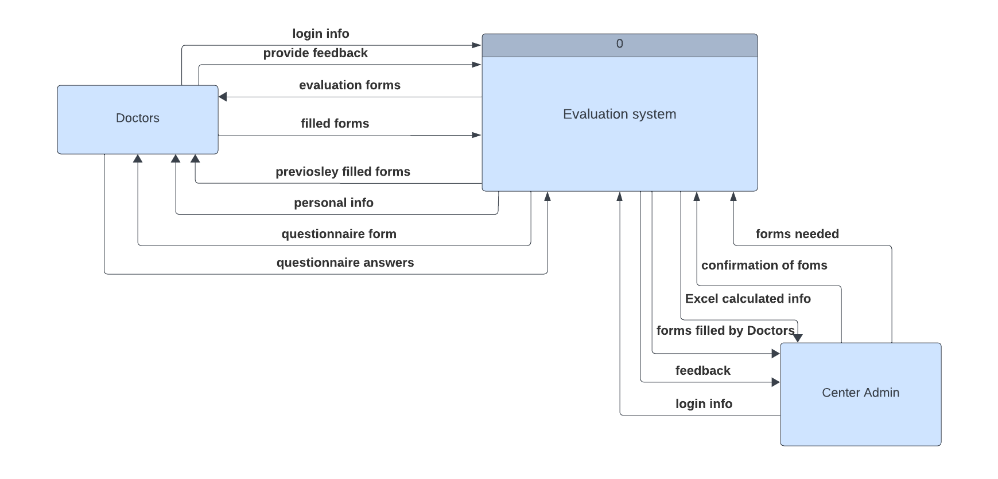

*Figure 5 Context Diagram*

* 1. Data Flow Diagram:

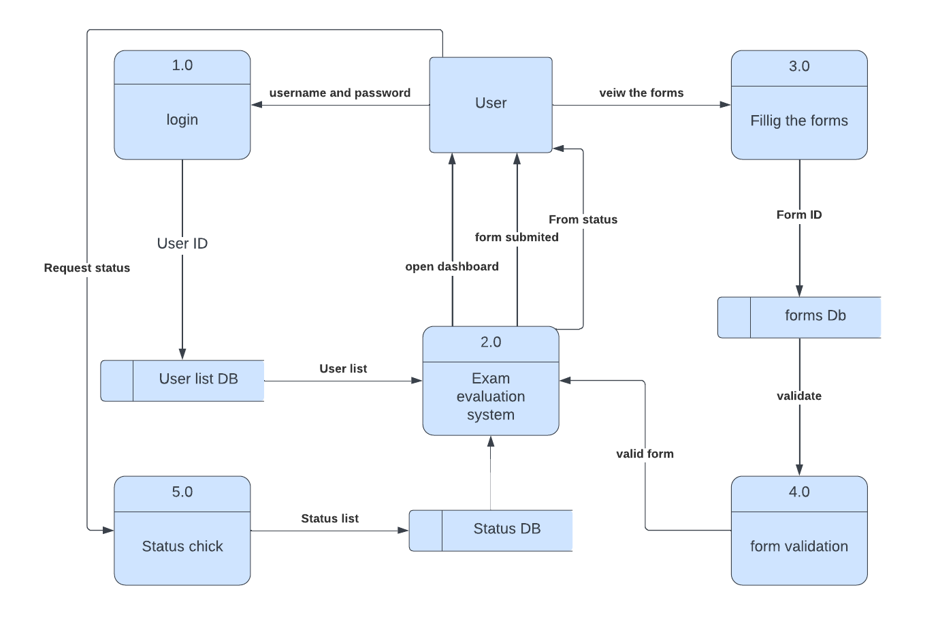

*Figure 6 Data Flow Diagram*

* 1. Entity Relationship Diagram:

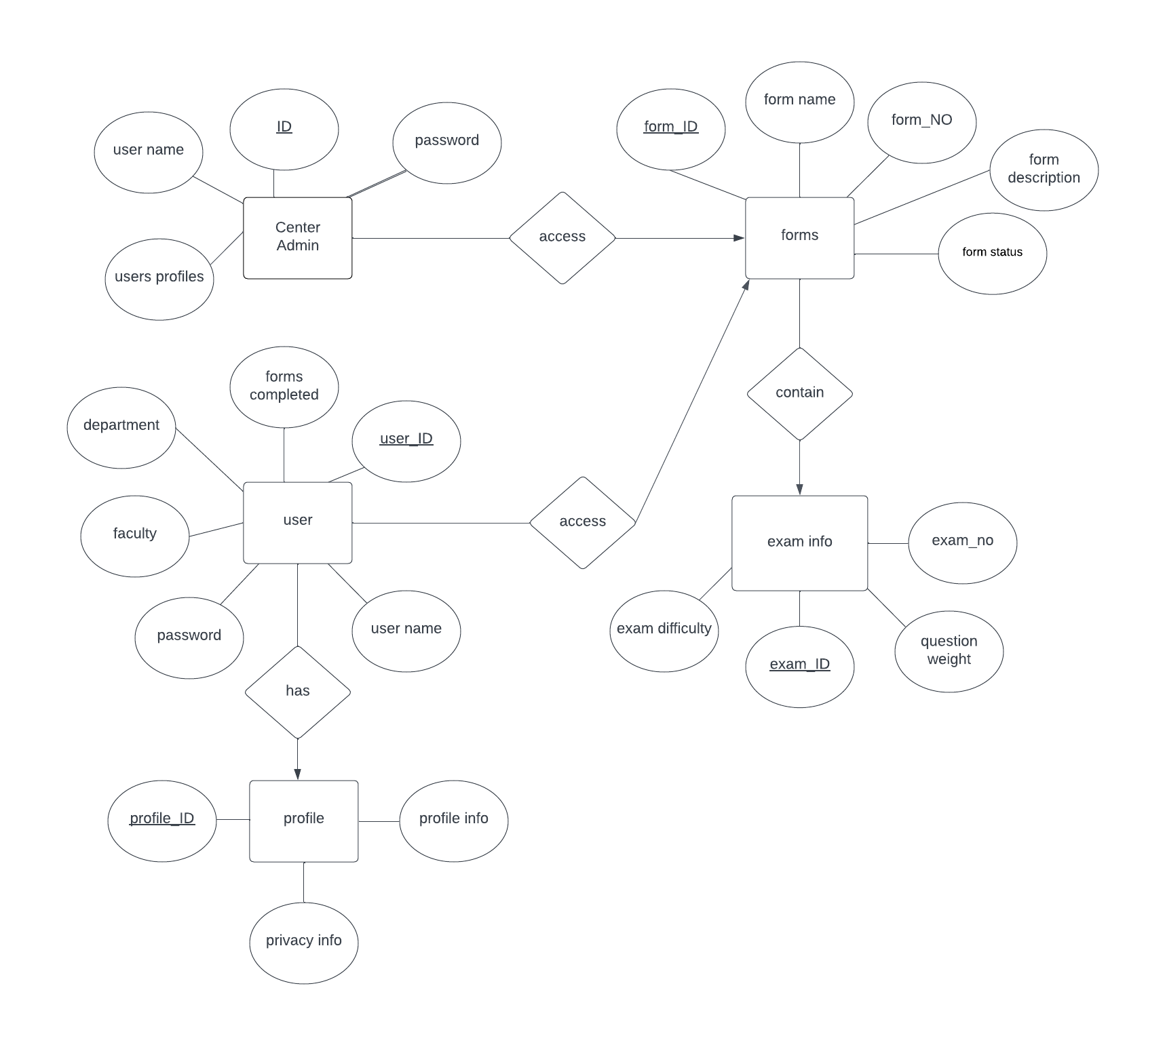

*Figure 7 ERD*

* 1. UML Use Case Diagram:

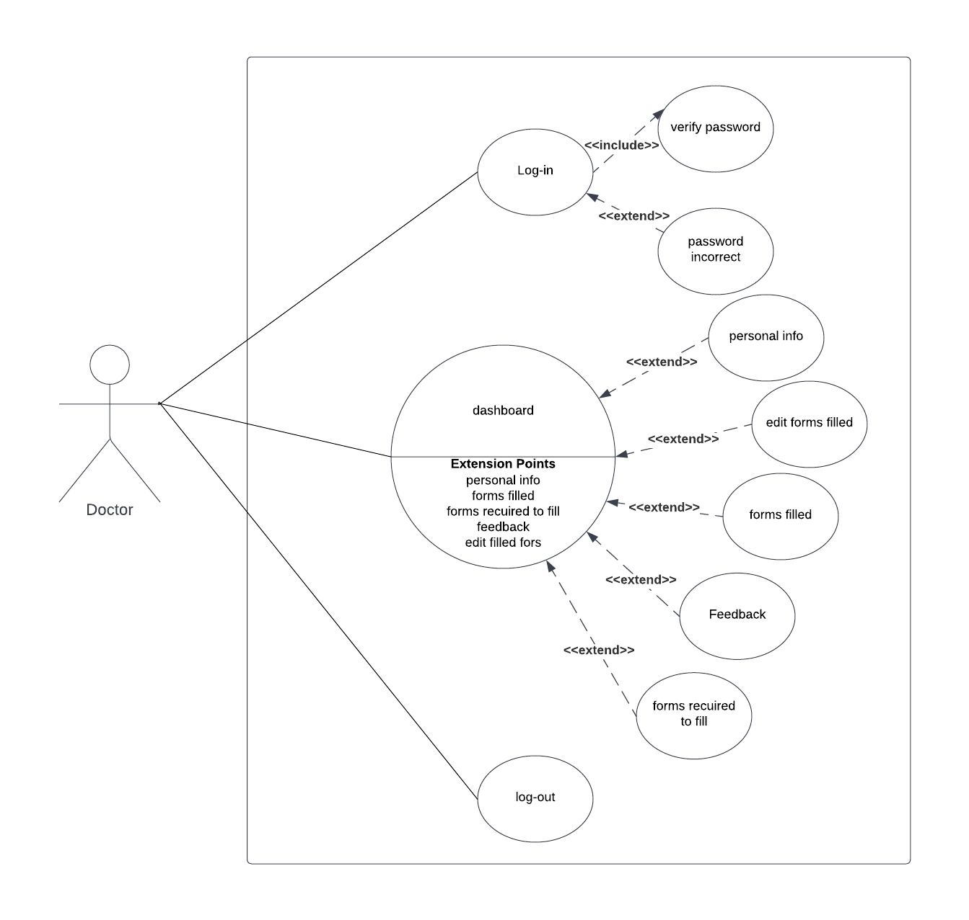

*Figure 8 Use Case Diagram*

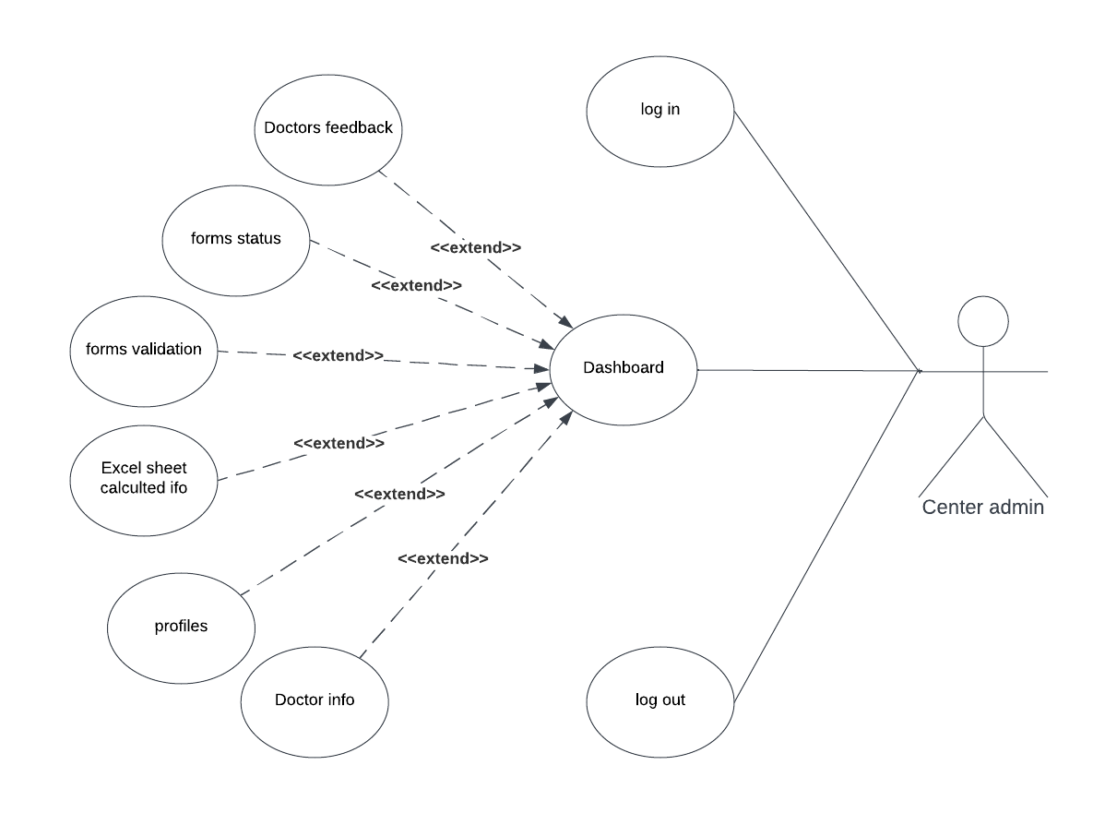

*Figure 9 Use Case Diagram*

* 1. UML Sequence Diagram:

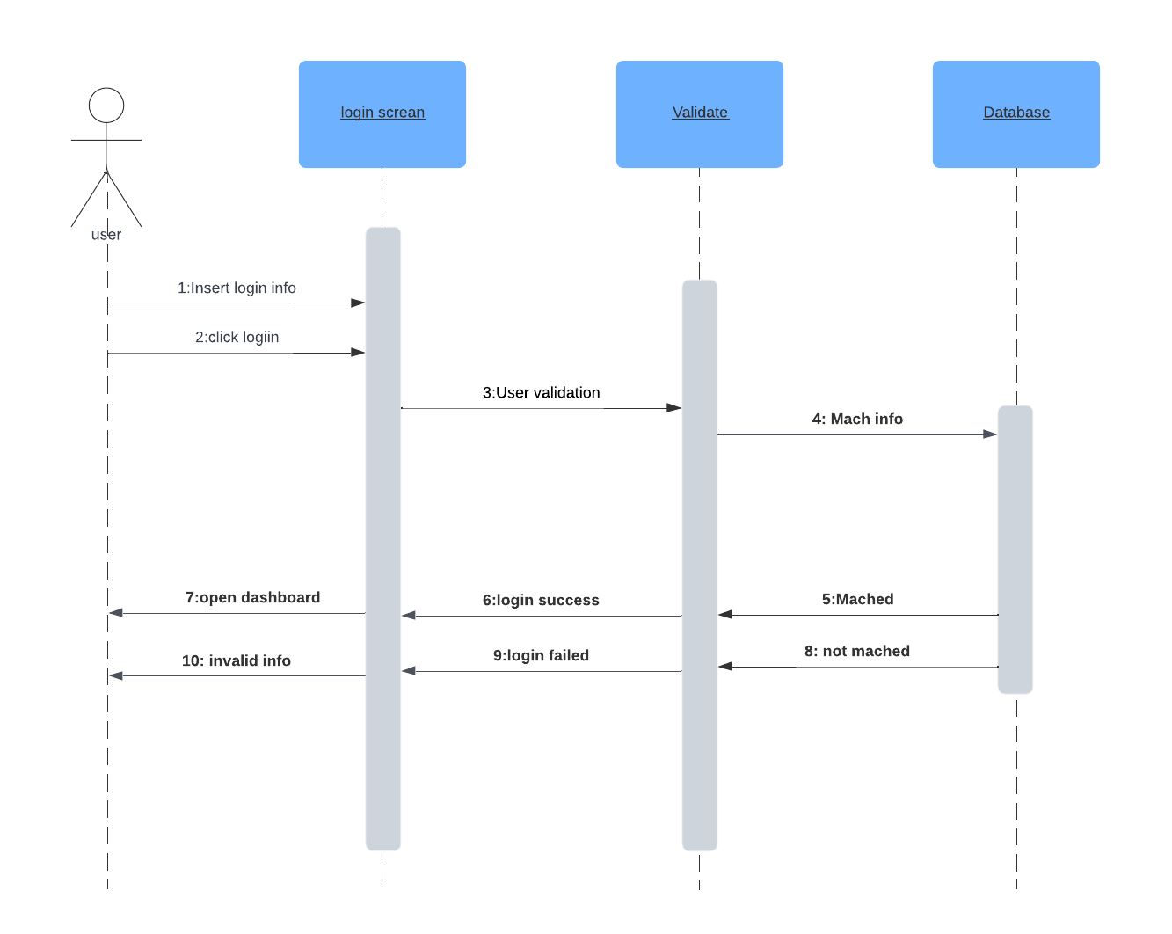

*Figure 10 Login Sequence Diagram*

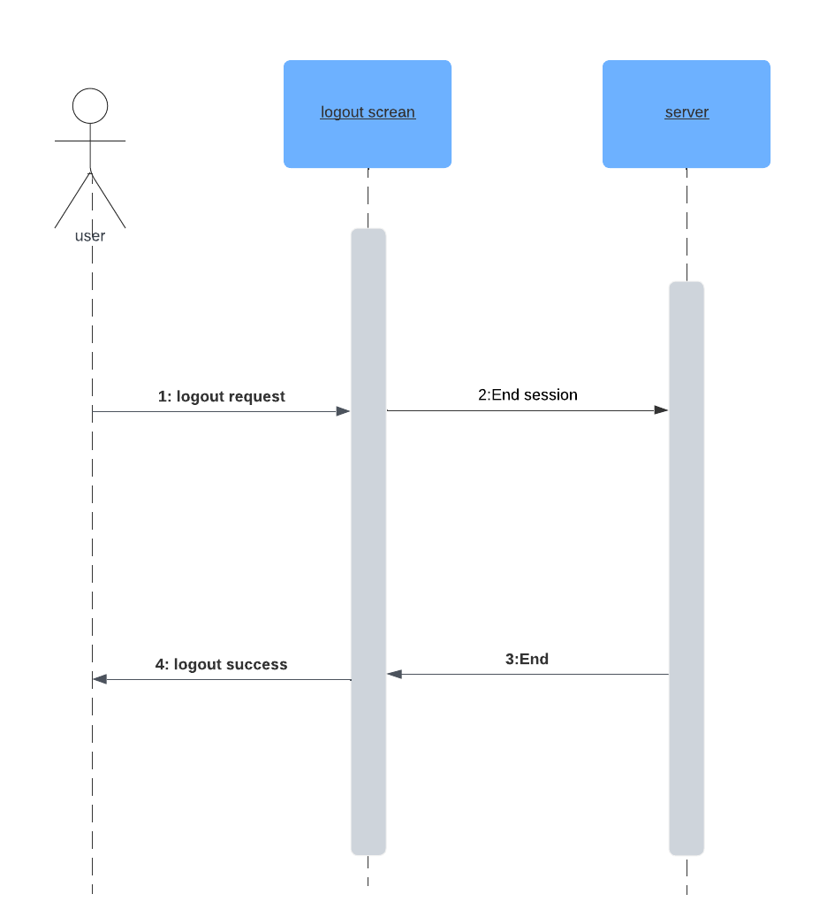

*Figure 11 Logout Sequence Diagram*

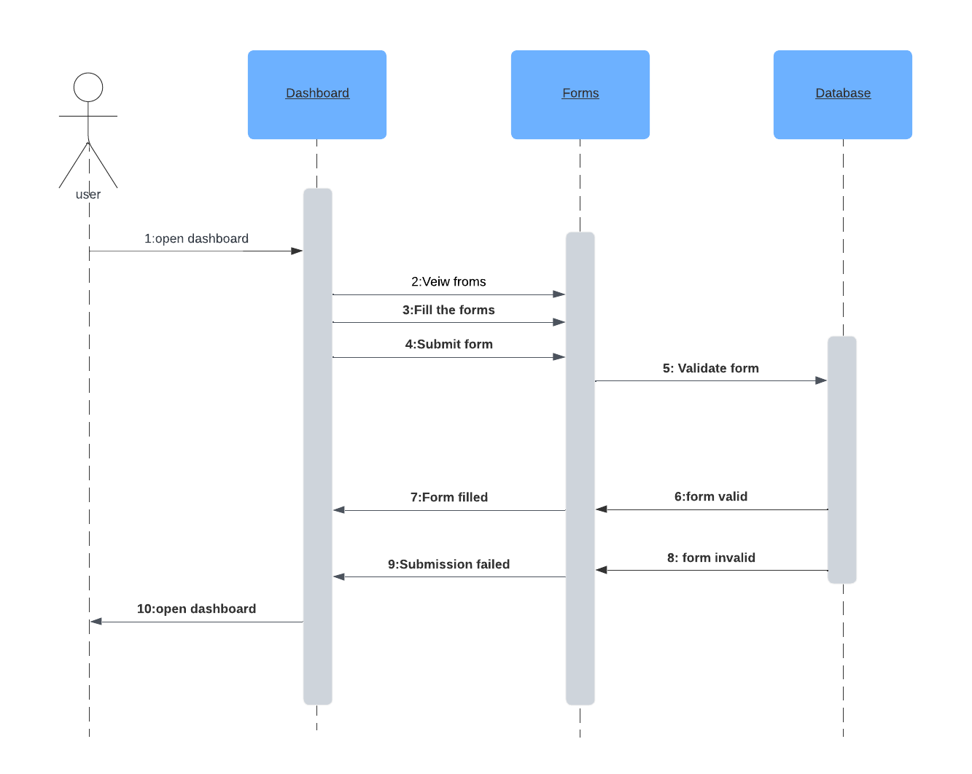

*Figure 12 Forms submission Sequence Diagram*

* 1. UML Class Diagram:

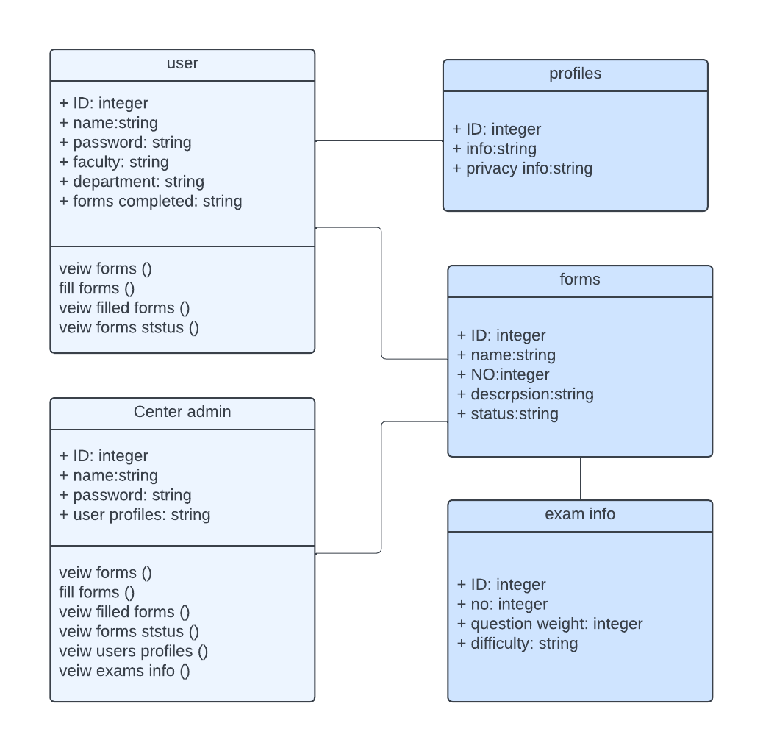

*Figure 13 UML Class Diagram*

* 1. Graphical User Interface Design:
  2. Summary:

In this chapter, we discussed our system design, where we presented our context, entity relationships, data flow, use cases, sequences, and class diagrams for our system.